

Self-priming pumps with
built-in strainer basket

ATS

OPERATING INSTRUCTIONS

- Operating conditions

Standard construction
-For clean or slightly dirty water circulation in swimming pool filtration systems, with a maximum temperature of 60℃.
-Maximum permissible working pressure up to 6 bar.
-Installation in well ventilated location protected from the weather, with a maximum ambient temperature of 40℃.

Noise level,
up to 2,2kW: ≤ 70 dB(A);
from 3 to 11kW: ≤85dB(A).

2.Installation

Lift and transport the pump as indicated in fig.1.
The AT pumps must be installed with the ro- toraxishorizontalanddeliveryport upwards.
Place the pump as close as possible to the suction source.

Provide clearance around the unit for motor ventilation, for easier inspection and mainte-
nance.

3.Pipes

Secure all pipes to supports and connect them
so that they do not transmit stress, strain or vibration to the pump.
The inside diameter of the pipe-work depends on the desired flow.
Provide a diameter assuring a liquid flow not greater than 1.5m/s for suction and 3 m/s for delivery
The pipe diameters must never be smaller than the pump connection ports.

3.1.Suction pipe

The suction pipe must be perfectly airtight and be led upwards in order to avoid air pockets.
lf operating with flexible hoses, use a reinf-
orced spiral suction hose in order to avoid hose narrowing due to a suction vacuum.
With a pump located above the water level (suction lift operation),fit a foot valve or a check valve on the suction connection.
With a pump located below water level (inflow under positive suction head) install a gate valve.

3.2.Delivery pipe

Fit a gate valve in the delivery pipe to adjust delivery, head, and absorbed power.
Install a pressure gauge.
With a geodetic head of over 15 m fit a check valve between the pump and the gate valve in order to protect the pump from water hammering.

4.Electrical connection


Electrical connection must be carri-
ed out by a qualified electrician in accordance with local regulations.
Follow all safety standards.
The unit must be properly earthed
(grounded).
Connect the earthing (grounding) cond- uctor to the terminal with the 〨marking.
Compare the mains voltage with the name-plate data and connect the supply conductors to the terminals in accordance with the apporpriate diagram inside the terminal box cover.
With motor power rating ≥ 5,5kw,
avoid direct starting.
Provide a control panel with star-delta
starting or an other starting.

ATTENTION: never allow washers or other metal parts to fall into the internal cable opening between the terminal box and stator.
lf this occurs, dismantle the motor to recover the object which has fallen inside.

For use in swimming pools, garden ponds and similar places, a residual current device with I△N not exceeding 30 mA must be installed in the supply circuit.

lnstall a device for disconnection from the mains(switch) with a contact separation of at least 3 mm on all poles.

With a three-phase motor install an overload protection device appropriate for the rated current of the pump.

Single-phase ATP pumps are supplied with a capacitor connected to the terminals and (for 220-240V-50Hz) with an incorporated thermal protector.

5.Starting

ATTENTION: never run the pump dry.
Start the pump after filling it with liquid.

When the pump is located above the water level (suction lift operation)fill the pump with water up to suction pipe level through the opening on the strainer after removing the cover
(fig.2).

ATTENTION: for transportation the cover is temporarily closed with hexagon nuts.

Replace them with the hand knobs
(15.12)located inside the filter.

When operating with the pump below water level (inflow under positive suction head),fill the pump by opening the suction gate valve slowly and completely, keeping the delivery gate valve open to release the air.

With a three-phase motor check that
the direction of rotation is as shown by the arrow on the pump casing, otherwise, disconnect electrical power and reverse the connections of two phases.

With a suction lift operation it may be necess-
ary to wait few minutes for the pump to prime.

Check that the pump works within its field of performance,and that the absorbed current shown on the name-plate is not exceeded.
Otherwise adjust the delivery gate valve.

6.Maintenance

Inspect and clean the strainer basket
periodically.
The strainer can be easily accessed by removing the strainer cover.With the pump located below water level,close the suction and delivery gate valves before removing the cover.


Disinfectant or chemical pro-

ducts for water treatmentmust not be poured directly into the pump.

Risk of reactions and emission of harmful fumes.
Risk of corrosion in stagnant water conditions (also with an increase in temperature and dec-
rease of pH value).

In the event of prolonged standstill periods or if freezing may be expected, drain the pump completely (fig.3).
Before restarting the unit, check that the shaft is not jammed and fill the pump casing with water.

Disconnect electrical power
before any servicing operation and make sure the pump cannot be accidentally switched on.

7.Dismantling

Close the suction and delivery gate
Valves and drain the pump casing before dis-
mantling the pump.
For dismantling and re-assembly see constr-
uction in the cross section drawing.
The motor and all internal parts can be dism-
antled without removing the pump casing and pipes.
By removing the nuts (14.28)the motor can be taken out complete with the impeller.

8.Spare parts

When ordering spare parts, please quote their designation, position number in the cross section drawing and rated data from the pump name plate(typ,date and serial number).
Use bearings with C3 clearance and grease for high temperatures.

Any pumps that require inspe-

ction/repair must be drained and carefully cleaned inside and out-

side before dispatch/submission.

Changes reserved.


Cross section drawings

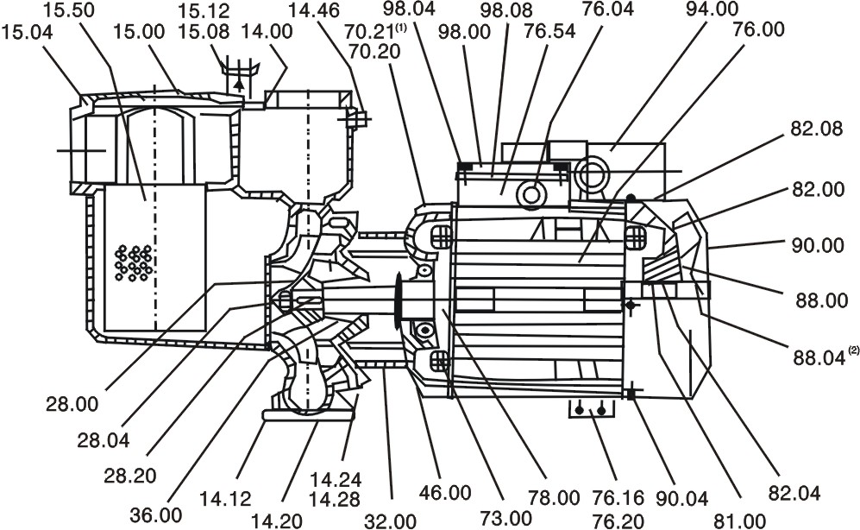

Only for types

AT400-2000

Nr . Designation
14.00 Pump casing
14.12 Plug (draining)
14.20 Gasket
14.24 Screw
14.28 Nut
14.46 Plug
15.00 Strainer cover
15.04 O-ring
15.08 Screw
15.12 Hand wheel
15.50 Strainer basket
28.00 lmpeller
28.04 lmpeller nut
28.20 Key
32.00 Lantern bracket
36.00 Mechanical seal
36.50 Circlip
46.00 Deflector
70.20 Screw
70.21 washer
73.00 Pump-side bearing
76.00 Motor casing with winding
76.04 Cable gland
76.16 Support
76.20 Pin
76.54 Terminal box,set
78.00 Shaft with rotor packet
81.00 Fan-side bearing
82.00 Motor end shield,fan side
82.04 Compensating spring
82.08 Screw
88.00 Motor fan
88.04 Circlip
90.00 Fan cover
90.04 Screw
94.00 Capacitor
98.00 Terminal box cover
98.04 Screw
98.08 Gasket


DECLARATION OF CONFORMITY
We AQUA S.P.A.declare that our Pumps AT
pump type and serial number shown on the name plate
are constructed in accordance with Directives 89/392/EEC, 91/368/EEC,93/44/EEC,93/68/EEC,89/336/EEC,92/31/EEC,73/23/EEC and assume full responsability for conformity with the standards laid down therein.

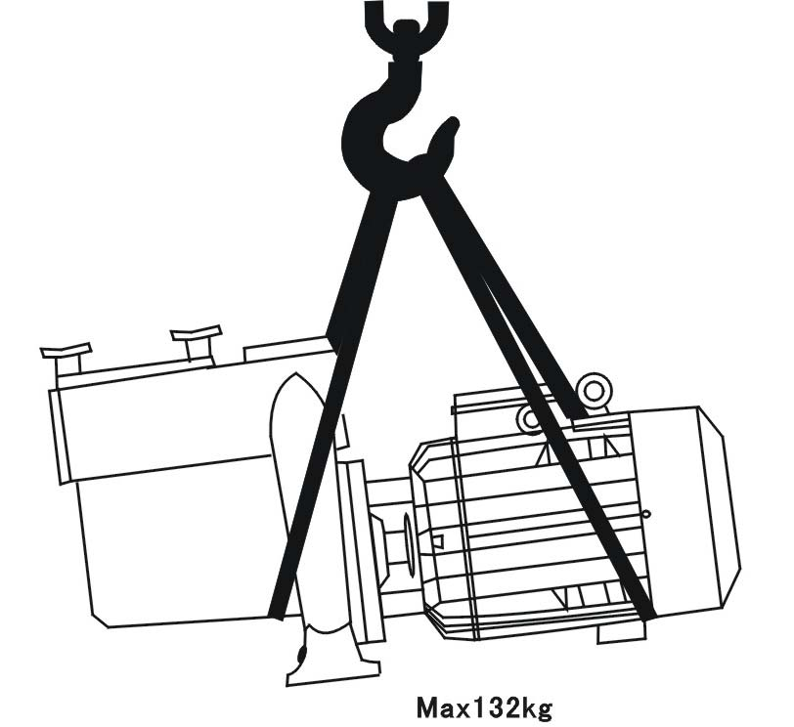
FIG. 1 Raising the pump

FIG.2 Filling
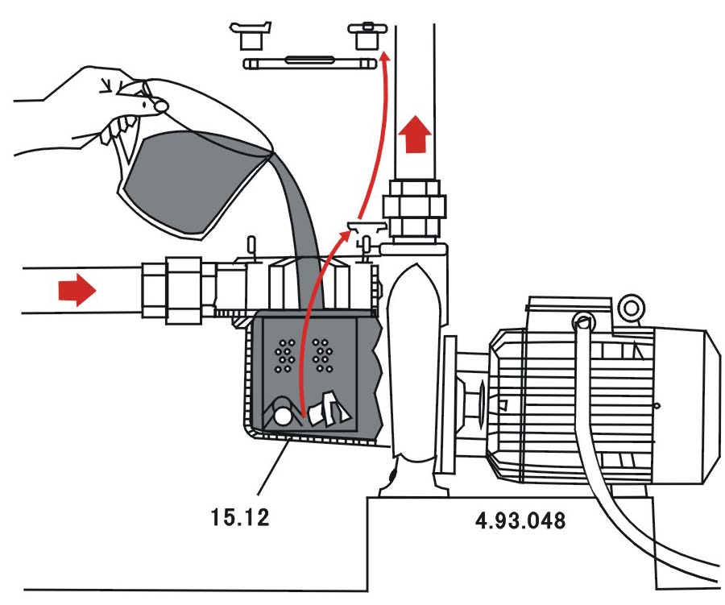

FIG.3 Draining

Air inlet
